University Of Information Technology


CS - 8317 Software Construction and Evolution
Buddy: Simplifying DevOps Automation
Project Report by Group 8
Members
1.Khine Zin Nyunt (4SE - 1229)
2.Paing Zay Khant (4SE - 1242)
3.Htet Arkar Oo (4SE - 1084)

TABLE OF CONTENTS
- INTRODUCTION........................................................................................3
1.1 Project Overview....................................................................................3
1.2 Objectives and Purpose .........................................................................3
- CI/CD PIPELINES ......................................................................................4
2.1 Configuration Management ..................................................................4
2.2 Understanding CI/CD ............................................................................4
2.3 Importance and Benefits of CI/CD .......................................................5
- TOOLS AND TECHNOLOGIES ..............................................................5
3.1 Buddy: CI/CD Automation Platform ...................................................5
3.2 GitHub: Version Control and Collaboration Platform ......................6
- IMPLEMENTATION ..................................................................................6
4.1 Project Creation in Buddy ....................................................................6
4.2 GitHub Repository Setup ......................................................................7
4.3 Integration of Buddy with GitHub .......................................................7
4.4 Pipeline Configuration and Setup ........................................................8
4.5 Deployment ...........................................................................................10
- CONCLUSION ..........................................................................................10
5.1 Takeaways from the Project ................................................................10
5.2 Solutions and Benefits ..........................................................................11
5.3 Final Reflections ...................................................................................11
REFERENCES .....................................................................................................12

1. INTRODUCTION

1.1 Project Overview
In this project, we will work towards building a CI/CD pipeline using Buddy, which is an automation platform specifically designed for DevOps workflows. GitHub is the version control it integrates with and then from development and till going live by getting automated – do everything you need the basic things GitHub takes care of.
The motive is to increase team collaboration and minimize any manual intervention by providing an automatic flow, enabling the code to be integrated,tested and deployed seamlessly.

1.2 Objectives and Purpose
The key objectives of this project are:
- Automating the build, test and deployment steps using Buddy CI/CD pipelines.
- Automating manual parts of the development workflow to speed up release cycles.
- Providing collaboration between development and QA teams through the automation of repetitive tasks.
This also shows how simple and powerful buddy is when it comes to tackle complex devops operations with ease.

2. CI/CD PIPELINES

2.1 Configuration Management
Configuration management is a series of methods and procedures for maintaining the consistency, operational status, control over code environment settings just as well the extensive infrastructure configurations across different stages in the life cycle. In this project, Buddy's pipelines handle every configuration automatically and are regularly executed in a consistent environment at each stage of the workflow.
With Buddy, teams are able to automate more than code deployments: environment setups and updates can be automated too – avoiding inconsistencies between development, staging and production.

2.2 Understanding CI/CD
CI (Continuous Integration) means that code changes are integrated into a shared repository frequently with each change resulting in an automated build and tests. This means that code is validated consistently and this helps to mitigate against integration problems.
CD (Continuous Deployment) works to deploy the validated code to the production environment so that its end users can get updates without interactions from developers. In one way or another, CI/CD enhances a fast and credible software delivery system.
In this project Buddy is responsible for the CI/CD process, meaning that every code pushed to the GitHub repository is automatically built and tested and deployed if the build passes the tests.
2.3 Importance and Benefits of CI/CD
CI/CD offers several advantages, including:
- Faster releases: Automating tasks like builds, tests, and deployments speeds up the entire release cycle.
- Higher code quality: Consequently, testing and validation procedures suggest that only correct code is released at times to the production area. .
- Improved team collaboration: With automated processes, developers, testers, and operations teams can work together more efficiently.
- Reduced manual errors: Automation results in good and standard schedules that in turn minimize human interferences in deployment processes. .

3. TOOLS AND TECHNOLOGIES

3.1 Buddy: CI/CD Automation Platform
Buddy is a DevOps automation tool, created with simplicity in mind – with its rich ecosystem it gives users the ability to set up CI/CD pipelines visually. It enables teams to design the processes easily by dragging action cards which helps to implement complex DevOps work without the necessary IT background of the team members.
Some of Buddy’s standout features include:
- Pre-configured actions: Buddy comes with a wide range of pre-configured actions, from code compilation to deployment and monitoring, making it easy to automate a wide array of tasks.
- Real-time feedback: Buddy updates the pipelines in real-time and gives teams working on the deployments proper insight into the pipelines.
- Collaboration: Through CI/CD, Buddy supports integration of tasks between developers, designers, and testers, as well as their subsequent coordination.

3.2 GitHub: Version Control and Collaboration Platform
GitHub is the most popular source control system where the project’s code is committed and shared among the team members and in public. This enables teams to track changes, create branches and manage the different versions of the codes in an efficient way.

Key features of GitHub for this project include:
- Pull requests: Co-ordinating code reviews and discussion that is conducted before merging the code changes to the main branch. .
- Branch protection: Ensuring that only the code that has been reviewed and passed through various test stages gets integrated to the production branches.
- Webhook integrations: Triggering Buddy pipelines automatically when changes are pushed to the repository, streamlining the CI/CD process.

4. IMPLEMENTATION
4.1 Project Creation in Buddy
The project starts with forming a new pipeline in Buddy. Buddy’s dashboard enables integration with external databases such as Github and the project is associated with the Github repository where the code is kept.
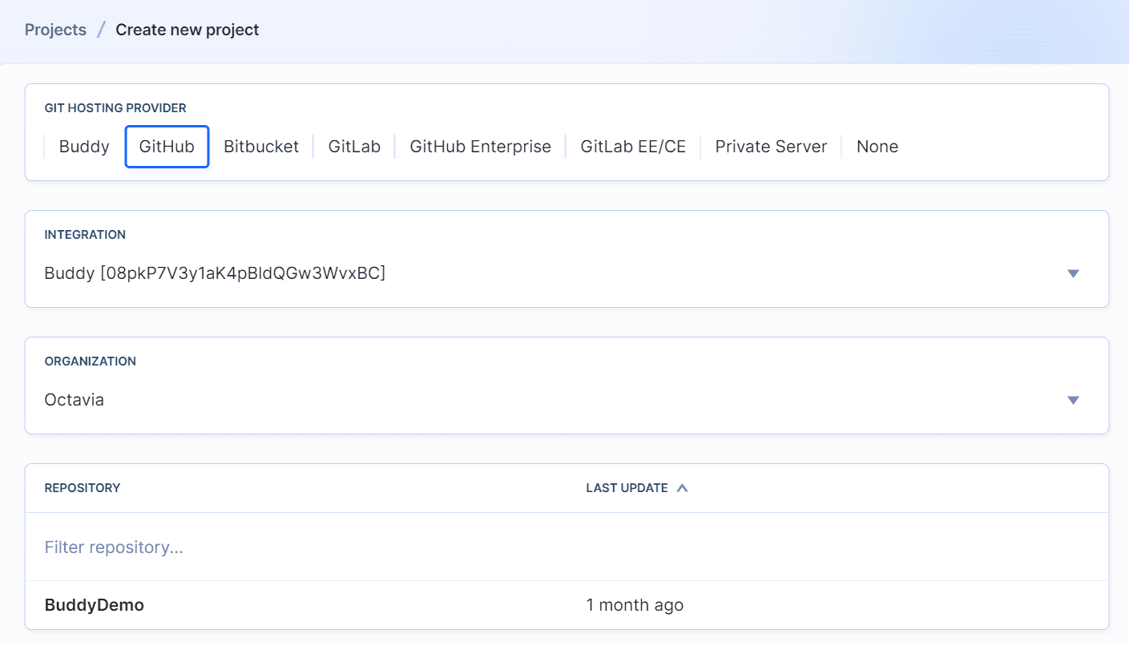
Figure 4.1: Selecting Github Repository

4.2 GitHub Repository Setup
In GitHub, the repository holds all the versions of the code, creates and controls branches while supporting teamwork. GitHub pull requests are used to submit changes to the main branch and to discuss and insist on changes requested on the features and additional updates.

4.3 Integration of Buddy with GitHub
By linking Buddy to the GitHub repository, any updates or code changes in the repository automatically trigger the CI/CD pipeline. Buddy interacts with GitHub through webhooks to guarantee that the workflows triggered are real-time, especially when codes are pushed or merged.

4.4 Pipeline Configuration and Setup
A CI/CD pipeline was created in Buddy’s interface, which facilitated the automation of the development workflow.
Here’s a set of steps that can be followed to set up the pipeline:
- Code Build: The first step in the Buddy process is to build the source code with all dependencies.
- Automated Testing: Once the code is built, Buddy tests it as well as the customer’s code to check any functional or nonfunctional issues that can arise in the development process.
- Deployment: Following completion of tests without errors, the next stage of the pipeline is to apply the code in the target environment.
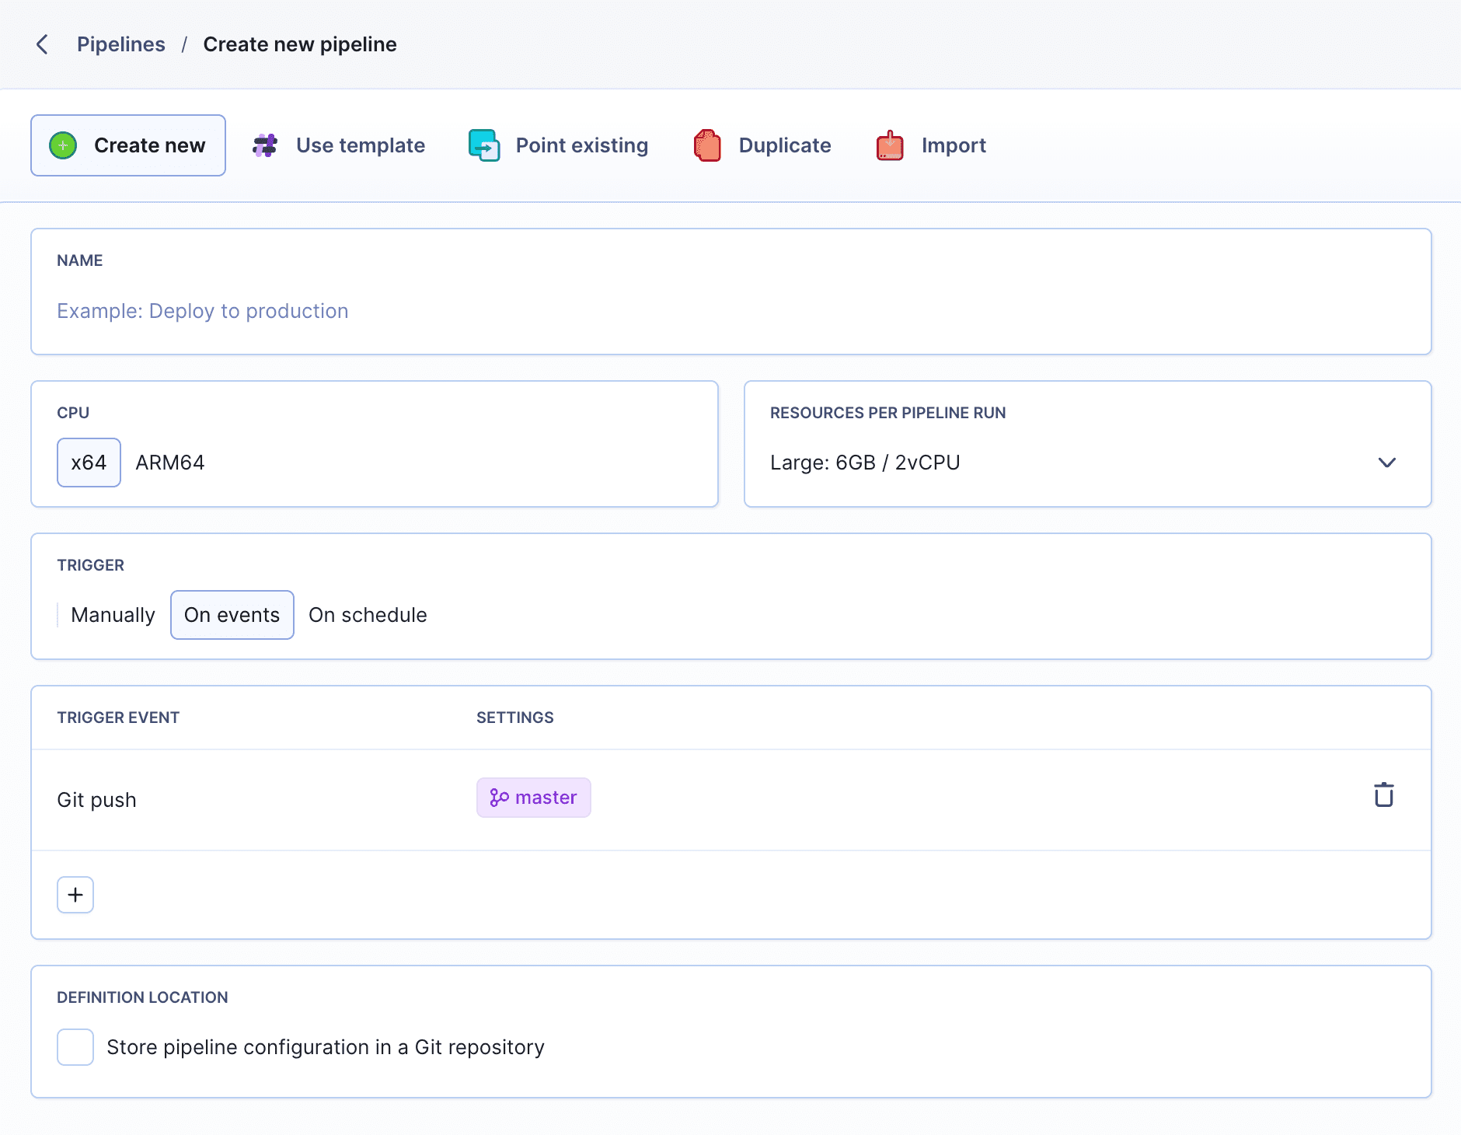
Figure 4.2: Exemplary pipeline settings
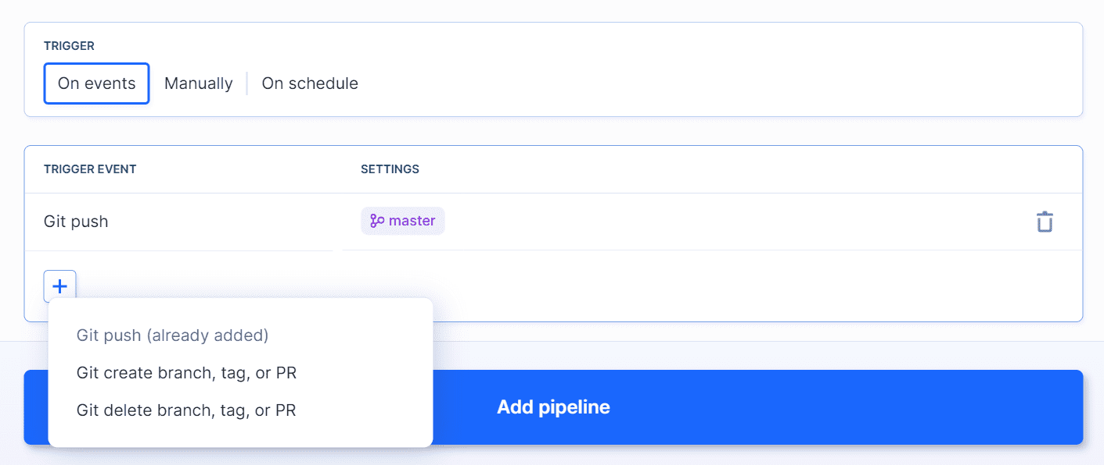
Figure 4.3: On event pipeline trigger mode

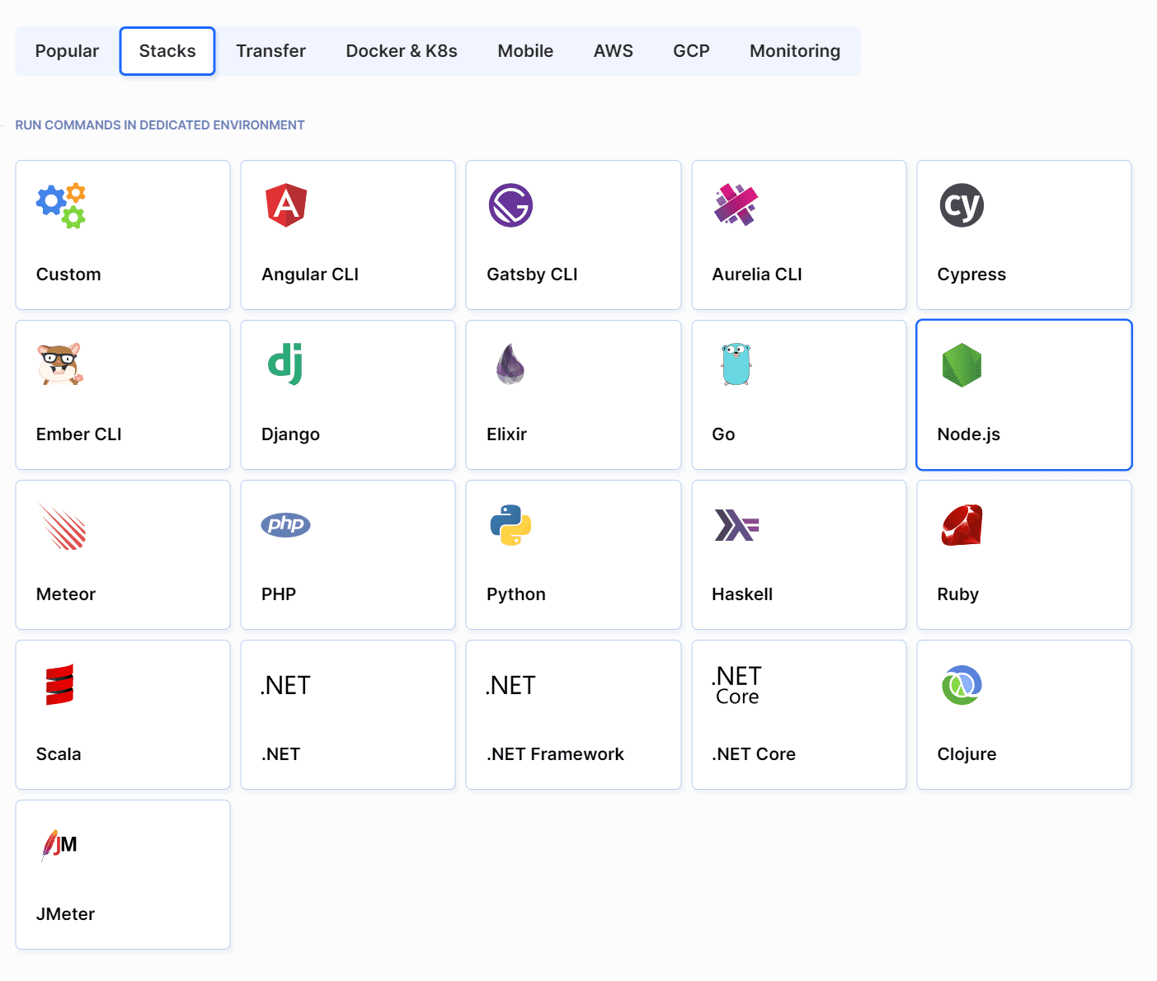
Figure 4.4: Action List
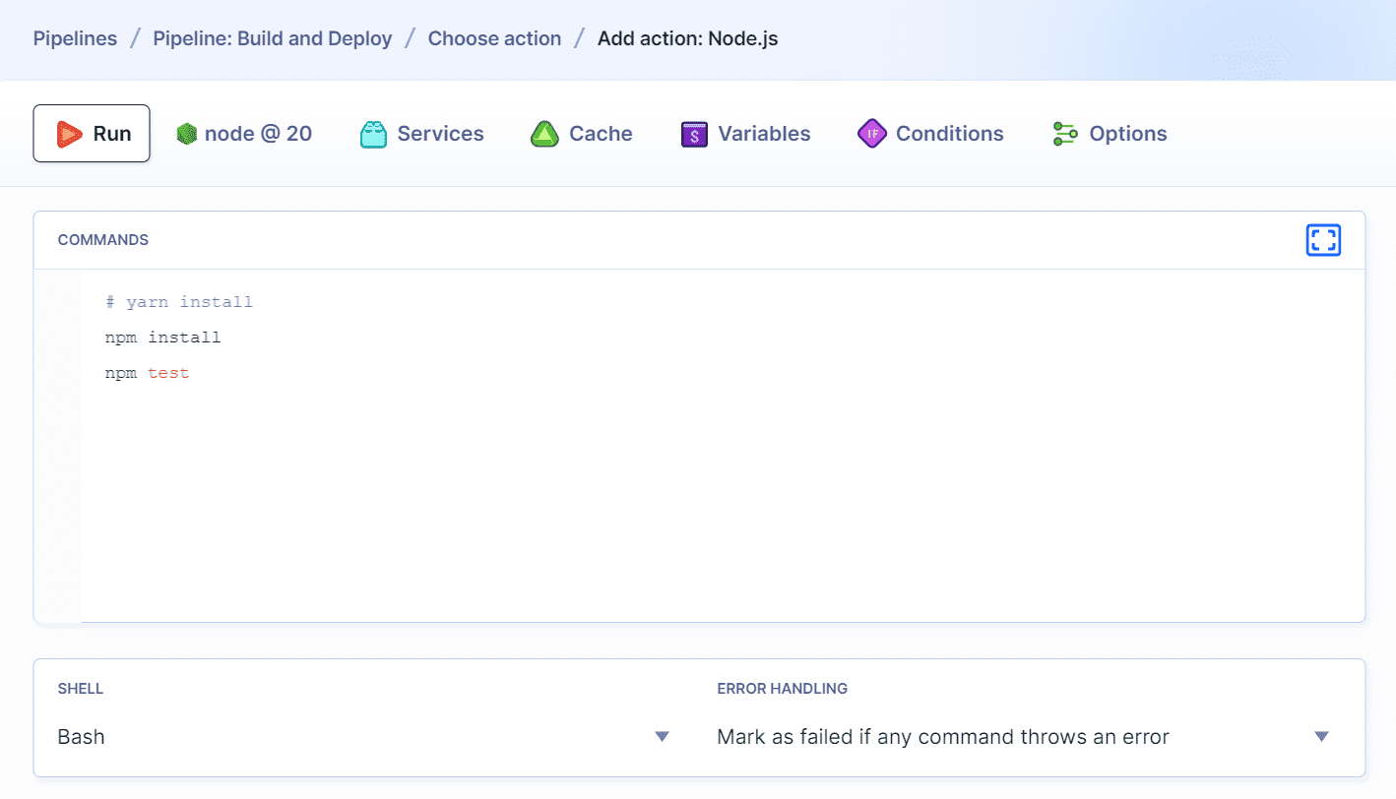
Figure 4.5: Default build commands

4.5 Deployment
In this project, deployment is automated by making use of the preset deployment actions in Buddy. The pipeline also contains safeguards that make sure the same set up is done on all environments and the most recent version of code that has passed test cases is deployed when necessary.

5. CONCLUSION

5.1 Takeaways from the Project
The work done in this project with the use of Buddy showed how quickly and easily it is possible to make the work on the CI/CD pipeline automation. Thanks to the graphical operations, the pipeline was effortlessly configured and together with GitHub, it provided the necessary environment for development and control.
Key takeaways include:
- Routine task automation fundamentally changes the process of testing and redeployment through time savings.
- The fact that Buddy can be linked with GitHub and fairly easy pipeline construction can elevate team performance due lowering the degree of human involvement in DevOps tasks.
- Feedback from the pipelines of Buddy allows detection of problems while the process is still ongoing thus making deployments less painful.
5.2 Solutions and Benefits
The strong solutions and benefits provided by this project include.
- Better effectiveness: Automated pipelines help in reducing time taken for putting code to production and test, as the most errors are corrected.
- Improved quality of code: There is constant assessment and testing and hence there is no chance of taking any faulty code to the production stage.
- Better teamwork: Implementation Of Visual Pipeline And User-Friendly Environment Enhances The Cooperation Between Developers, Testers And Designers.
5.3 Final Reflections
Buddy’s user-friendly design and robust automation capabilities proved to be an invaluable tool in this project. By automating CI/CD processes, the development workflow was streamlined, leading to faster releases and improved team collaboration.

REFERENCES
- Buddy Documentation
Buddy. “How to Set Up Pipelines.” Buddy Docs, Buddy Works, https://buddy.works/docs.
This source provides comprehensive information on setting up CI/CD pipelines, integrating with GitHub, and automating deployments using Buddy.
- GitHub Documentation
GitHub. “GitHub Webhooks Overview.” GitHub Docs, GitHub, https://docs.github.com/en/developers/webhooks-and-events/webhooks.
Detailed guidelines on configuring webhooks for automating workflows like CI/CD pipelines using Buddy.
- J. Humble and D. Farley,
Continuous Delivery: Reliable Software Releases through Build, Test, and Deployment Automation. Addison-Wesley, 2010.
A foundational book on continuous integration and continuous delivery practices, providing insight into building robust CI/CD systems.
- P. Debois,
The DevOps Handbook: How to Create World-Class Agility, Reliability, & Security in Technology Organizations. IT Revolution Press, 2016.
This book explores the role of automation in DevOps workflows, supporting the rationale behind using Buddy for streamlining operations.

